Trading Strategy Tester

Software Requirements Specification

0.02

10.09.2015

Eduard Kovalets
Lead Software Engineer

Prepared for
WSU-TC CptS 322—Software Engineering Principles I
Instructor: Saleh Hadi, Ph.D.
2015

Revision History

Date | Description | Author | Comments
10.09.2015 | Scope and purpose of project | Eduard Kovalets | <First Revision>
13.09.2015 | Use cases and other system requirements defined | Eduard Kovalets
30.09.2015 | Use cases diagrams and functional requirements | Eduard Kovalets

Document Approval

The following Software Requirements Specification has been accepted and approved by the following:
Signature | Printed Name | Title | Date
 | Eduard Kovalets | Lead Software Eng.
 | Ph.D. Hadi Saleh | Instructor, CptS 322

Table of Contents

Revision History ii
Document Approval ii
1. Introduction 1
1.1 Purpose 1
1.2 Scope 1
1.3 Definitions, Acronyms, and Abbreviations 1
1.4 References 1
1.5 Overview 1
2. General Description 2
2.1 Product Perspective 2
2.2 Product Functions 2
2.3 User Characteristics 2
2.4 General Constraints 2
2.5 Assumptions and Dependencies 2
3. Specific Requirements 2
3.1 External Interface Requirements 3
3.1.1 User Interfaces 3
3.1.2 Hardware Interfaces 3
3.1.3 Software Interfaces 3
3.1.4 Communications Interfaces 3
3.2 Functional Requirements 3
3.2.1 <Functional Requirement or Feature #1> 3
3.2.2 <Functional Requirement or Feature #2> 3
3.3 Use Cases 3
3.3.1 Use Case #1 3
3.3.2 Use Case #2 3
3.4 Classes / Objects 3
3.4.1 <Class / Object #1> 3
3.4.2 <Class / Object #2> 3
3.5 Non-Functional Requirements 4
3.5.1 Performance 4
3.5.2 Reliability 4
3.5.3 Availability 4
3.5.4 Security 4
3.5.5 Maintainability 4
3.5.6 Portability 4
3.6 Inverse Requirements 4
3.7 Design Constraints 4
3.8 Logical Database Requirements 4
3.9 Other Requirements 4
4. Analysis Models 4
4.1 Sequence Diagrams 5
4.3 Data Flow Diagrams (DFD) 5
4.2 State-Transition Diagrams (STD) 5
5. Change Management Process 5
A. Appendices 5
A.1 Appendix 1 5
A.2 Appendix 2 5

1. Introduction
This document describes a Trading Strategy Tester software product. It covers all details from requirements to detailed design.

1.1 Purpose
This SRS is required to describe project and plan its implementation. It will explain the purpose and features of the system, the interfaces of the system, what the system will do, the constraints under which it must operate and how the system will react to external stimuli. This document is intended for both the stakeholders and the developers of the system.

1.2 Scope

This will be an algorithmic trading strategy tester on historical data. The aim of this software product to help traders to test their trading ideas and strategies and forecast ideas productivity.
Usually financial market traders required to look through historical data and different trading indicators values to calculate productivity of their trading idea. This software product will have to automate described actions and increase productivity of traders by allowing them to focus on ideas and let all boring and routine job to machine.

The interesting part of the systems that it will allow to take into calculation the brokers commissions. It can also be extended to emulate real market behavior – like rejected orders, network delays – to make trading emulation more close to real world.

The system will provide graphical report on testing results.

The results of testing will be published in database and will allows manager to see reports approve them.

1.3 Definitions, Acronyms, and Abbreviations
Term | Definition
Trader | A person who make orders buy or sell for particular financial instrument on financial market.
Trading Strategy (Strategy) | A plan that describes in what moment one should buy financial instrument and/or sell financial instrument.
Database | A storage that manages all historical data.
Order | A format request to broker that ask to put a trade on the financial market.
Financial Market | A market where
Software Requirements Specification | A document that completely describes all of the functions of a proposed system and the constraints under which it must operate. For example, this document.
Stakeholder | Any person with an interest in the project who is not a developer.

1.4 References
IEEE. IEEE Std 830-1998 IEEE Recommended Practice for Software Requirements Specifications. IEEE Computer Society, 1998.

1.5 Overview
The next chapter, the Overall Description section, of this document gives an overview of the functionality of the product. It describes the informal requirements and is used to establish a context for the technical requirements specification in the next chapter.
The third chapter, Requirements Specification section, of this document is written primarily for the developers and describes in technical terms the details of the functionality of the product.
Both sections of the document describe the same software product in its entirety, but are intended for different audiences and thus use different language.

2. General Description

2.1 . System Environment
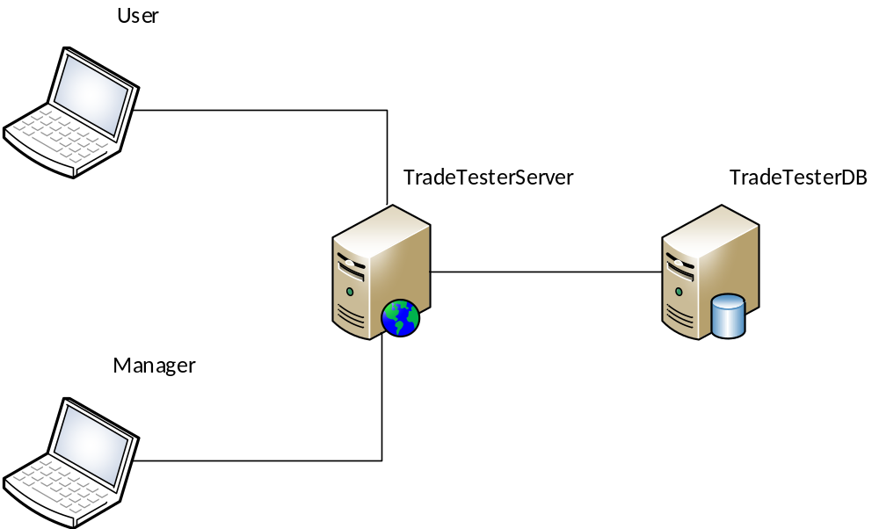
Figure 1 - System Environment

The system will have two types of actors – a User and a Manager. The Users will be able to upload their trading strategies realization into the Tester and see the results of trading emulation; they will be able to choose one of many historical data to use for their test. Managers will be able to manage system: to see users statistics, to setup testing profiles, to upload or setup historical data sources. As on optional requirement, the system could have a functionality to download historical data directly from source – like quandl or yahoo finance.
The results of trading emulation will be represented as profit graph and a table with detailed results for each trade bellow it.
The system itself will have two software components Test Manager and Test Runner. Test Manager will be responsible for scheduling test runner jobs, receive results and provide information to users. Test Runner will be responsible for test execution and provision of statistics on test for Tests Manager component.
All administration of the system will be done from operation system so we do not need to define role for administrator. Administrator will also create initial manager role during system setup.

2.2. Functional Requirements Specification
We decided to present function requirements as use cases, so this section will describe use-cases for each user and each particular situation.
2.2.1. Use case: User login into the system
Diagram:
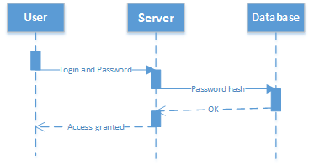
Brief Description:
Prior to start work with the system user must login – means enter user id and password.
Step-By-Step Description:
- User enters login page
- User provide user ID
- User provide password
- User press login button
- If userID and password are correct user session start and user sees working screen
- If userID and password are incorrect then user returns to login page with error message.
Xref: 3.1.1.

2.2.2. Use case: User upload trading strategy
Diagram:
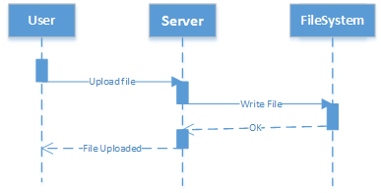
Brief Description:
From the working screen of user one can upload his trading strategy into account. This trading strategy will late be used in test
Step-By-Step Description:
- In active user session, from working screen.
- User press Upload strategy button
- He choose file to upload and press OK
- File goes to server and stores there
Xref: 3.1.2.
2.2.3. Use case: User run test
Diagram:
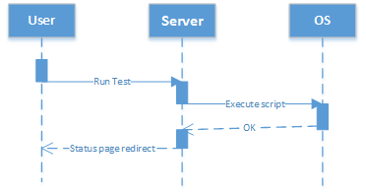
Brief Description:
User must be able to run test and get results
Step-By-Step Description:
- From active user session, from working screen.
- User press create test button
- He redirects to test creation page
- On test creation page user sets up test name
- On test creation page user chooses strategy (from uploaded earlier)
- On test creation page user chooses testing profile (from created by manager)
- User pushes create button
- User been returned to working screen where he see current test state
Xref: 3.1.3.
2.2.4. Use case: Manager login into the system
Diagram:
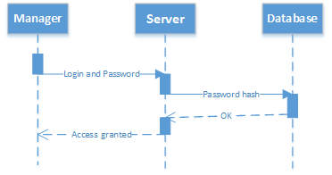
Brief Description:
Prior to start work with the system manager must login – means enter manager id and password.
Step-By-Step Description:
- Manager enters login page
- Manager provide Manager ID
- Manager provide password
- Manager press login button
- If Manager id and password are correct Manager session start and Manager sees working screen
- If Manager ID and password are incorrect then Manager returns to login page with error message.
Xref: 3.1.4.

2.2.5. Use case: Manager creates user account in the system
Diagram:
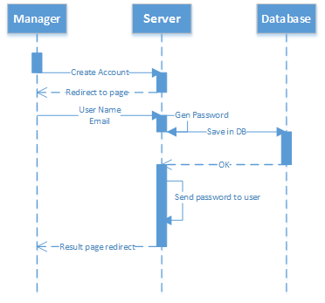
Brief Description:
Manager must be able to create new users accounts. For now it is the only way of how user accounts can be created.
Step-By-Step Description:
- In active manager session, from manager working screen
- Manager press create user button
- Manager been redirected to user creation page
- Manager enters user name.
- Manager enter s user email – it also will be user ID.
- Manager press create user.
- The system will generate password and send it to user email address (and email will be used as login).
Xref: 3.1.5.
2.2.6. Use case: Manager uploads test historical data
Diagram:
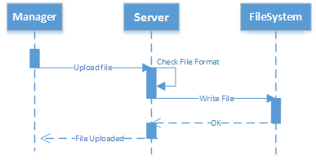
Brief Description:
All test are run on historical data, so we must have historical data in our system. Manager is the only person who can upload historical data.
Step-By-Step Description:
- From manager working screen and active manager session
- Manager press upload button
- Manager chooses file from operation system
- Files uploads to server
- Server verifies file format and save it in the specific folder
Xref: 3.1.6
2.2.7. Use case: Manager creates testing profile
Diagram:
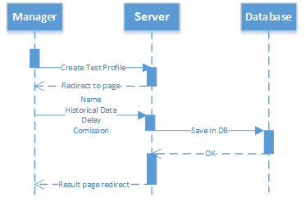
Brief Description:
Manager is the role that can create test profiles. Test profiles contains number of parameters that will be applied to test (e.g. historical data to use, brokerage commission per trade, time delay and so on depending on needs).
Step-By-Step Description:
- From manager working screen and active manager session
- Manager goes to profile creation page
- At profile creation page manager enter profile name
- At profile creation page manager chooses historical data (from previously uploaded by manager)
- At profile creation page manager setups brokerage commission rates.
- Manager presses create button and been redirected to working page of manager.
Xref: 3.1.7

2.2.8. Use case: Manager gets tests statistics
Diagram:
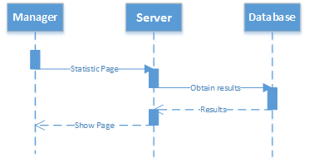
Brief Description:
Manager must be able to monitor testing statistics for all users, to be able to choose best result strategy.
Step-By-Step Description:
- From manager working page and active manager session
- Manager goes to statistics page
- At the statistics page manager can see the list of all test results in a table
- Manager can filter results by user, sort them by profit or by drowdown.
Xref: 3.1.8

2.3 User Characteristics
To use the system user must be able implement trading strategy so he must be able to program on python. He also need to have literacy on financial market trading to understand test results.
Manager must have understanding of csv format to provide historical data to the system.
Both users must have basic internet literacy to use web-based system.

2.4 Non-Functional Requirements
The Trading Strategy Tester will be on a server with high-speed Internet capability. The server and database will be deployed on Virtual Hosting Server provider or and Amazon Web Services.
All historical data will be stored in MongoDB database (alternatively on KDB+) and testing system related data in SQLite database or MySQL (MongoDB also can be used for that).
Users and manager can use any web browser to access the system.

3. Specific Requirements
All client requirements from previous chapter will be detailed in this section.

3.1. Functional Requirements

3.1.1. User login into the system
Use Case Name | User login into the system
XRef | Section 2.2.1, User login into the system
Trigger | User visits Trading System login page.
Precondition | User is not logged in.
Basic Path | - User enters login page  - User provide user ID  - User provide password  - User press login button  - If userID and password are correct user session start and user sees working screen  - If userID and password are incorrect then user returns to login page with error message.
Alternative Paths | n/a
Postcondition | Access to the system is granted to user
Exception Paths | n/a
Comments | n/a

3.1.2. User login into the system
Use Case Name | User upload trading strategy
XRef | Section 2.2.2, User uploads trading strategy
Trigger | User visits Trading System main page.
Precondition | User is logged in.
Basic Path | - In active user session, from working screen.  - User press Upload strategy button  - He choose file to upload and press OK  - File goes to server and stores there
Alternative Paths | n/a
Postcondition | Server stores file at specific folder on filesystem.
Exception Paths | n/a
Comments | n/a

3.1.3. User run test
Use Case Name | User run test
XRef | Section 2.2.3, User run test
Trigger | User visits Trading System main page.
Precondition | User is logged in.
Basic Path | - User press create test button  - He redirects to test creation page  - On test creation page user sets up test name  - On test creation page user chooses strategy (from uploaded earlier)  - On test creation page user chooses testing profile (from created by manager)  - User pushes create button  - User been returned to working screen where he see current test state
Alternative Paths | n/a
Postcondition | Server runs test
Exception Paths | n/a
Comments | n/a

3.1.4. Manager login into the system
Use Case Name | Manager login into the system
XRef | Section 2.2.4, Manager login into the system
Trigger | Manager visits Trading System login page.
Precondition | Manager is not logged in.
Basic Path | - Manager enters login page  - Manager provide Manager ID  - Manager provide password  - Manager press login button  - If Manager id and password are correct Manager session start and Manager sees working screen  - If Manager ID and password are incorrect then Manager returns to login page with error message.
Alternative Paths | n/a
Postcondition | Access to the system is granted to manager
Exception Paths | n/a
Comments | n/a

3.1.5. Manager creates user account in the system
Use Case Name | Manager creates user account in the system
XRef | Section 2.2.5, Manager creates user account in the system
Trigger | Manager visits Trading System main page.
Precondition | Manager is logged in.
Basic Path | - From manager working screen  - Manager press create user button  - Manager been redirected to user creation page  - Manager enters user name.  - Manager enter s user email – it also will be user ID.  - Manager press create user.  - The system will generate password and send it to user email address (and email will be used as login).
Alternative Paths | n/a
Postcondition | User account created and emails with password sent
Exception Paths | n/a
Comments | n/a

3.1.6. Manager uploads test historical data
Use Case Name | Manager uploads test historical data
XRef | Section 2.2.6, Manager uploads test historical data
Trigger | Manager visits Trading System main page.
Precondition | Manager is logged in.
Basic Path | - From manager working screen and active manager session  - Manager press upload button  - Manager chooses file from operation system  - Files uploads to server  - Server verifies file format and save it in the specific folder
Alternative Paths | n/a
Postcondition | File saved in specific folder at server
Exception Paths | n/a
Comments | n/a

3.1.7. Manager creates testing profile
Use Case Name | Manager creates testing profile
XRef | Section 2.2.7, Manager creates testing profile
Trigger | Manager visits Trading System main page.
Precondition | Manager is logged in.
Basic Path | - From manager working screen and active manager session  - Manager goes to profile creation page  - At profile creation page manager enter profile name  - At profile creation page manager chooses historical data (from previously uploaded by manager)  - At profile creation page manager setups brokerage commission rates.  - Manager presses create button and been redirected to working page of manager.
Alternative Paths | n/a
Postcondition | Profile created
Exception Paths | n/a
Comments | n/a

3.1.8. Manager get tests statistics
Use Case Name | Manager get tests statistics
XRef | Section 2.2.8, Manager get tests statistics
Trigger | Manager visits Trading System main page.
Precondition | Manager is logged in.
Basic Path | - From manager working page and active manager session  - Manager goes to statistics page  - At the statistics page manager can see the list of all test results in a table  - Manager can filter results by user, sort them by profit or by drowdown.
Alternative Paths | n/a
Postcondition | n/a
Exception Paths | n/a
Comments | n/a

3.2. External Interface Requirements
System have an optional requirement to be able to integrate with historical data providers like Quandl or Yahoo Finance.

3.2.1 Quandl

In this case communication with Quandl will be done over web-API and specification can be found here:
https://www.quandl.com/help/api

3.2.2. Yahoo Finance

In this case communication with Yahoo will be done over web-API and specification can be found here:
https://developer.yahoo.com/yql

3.3. Detailed Non-Functional Requirements

3.3.1 Security

The system will support effective level of security by using authorization and a requirement that no action can be executed by non-authorized user (e.g. user with in active session or without necessary rights or roles).

